**Create a VM and encrypt the data disk attached to the VM by enabling Azure disk encryption**

1. **create A resource group**

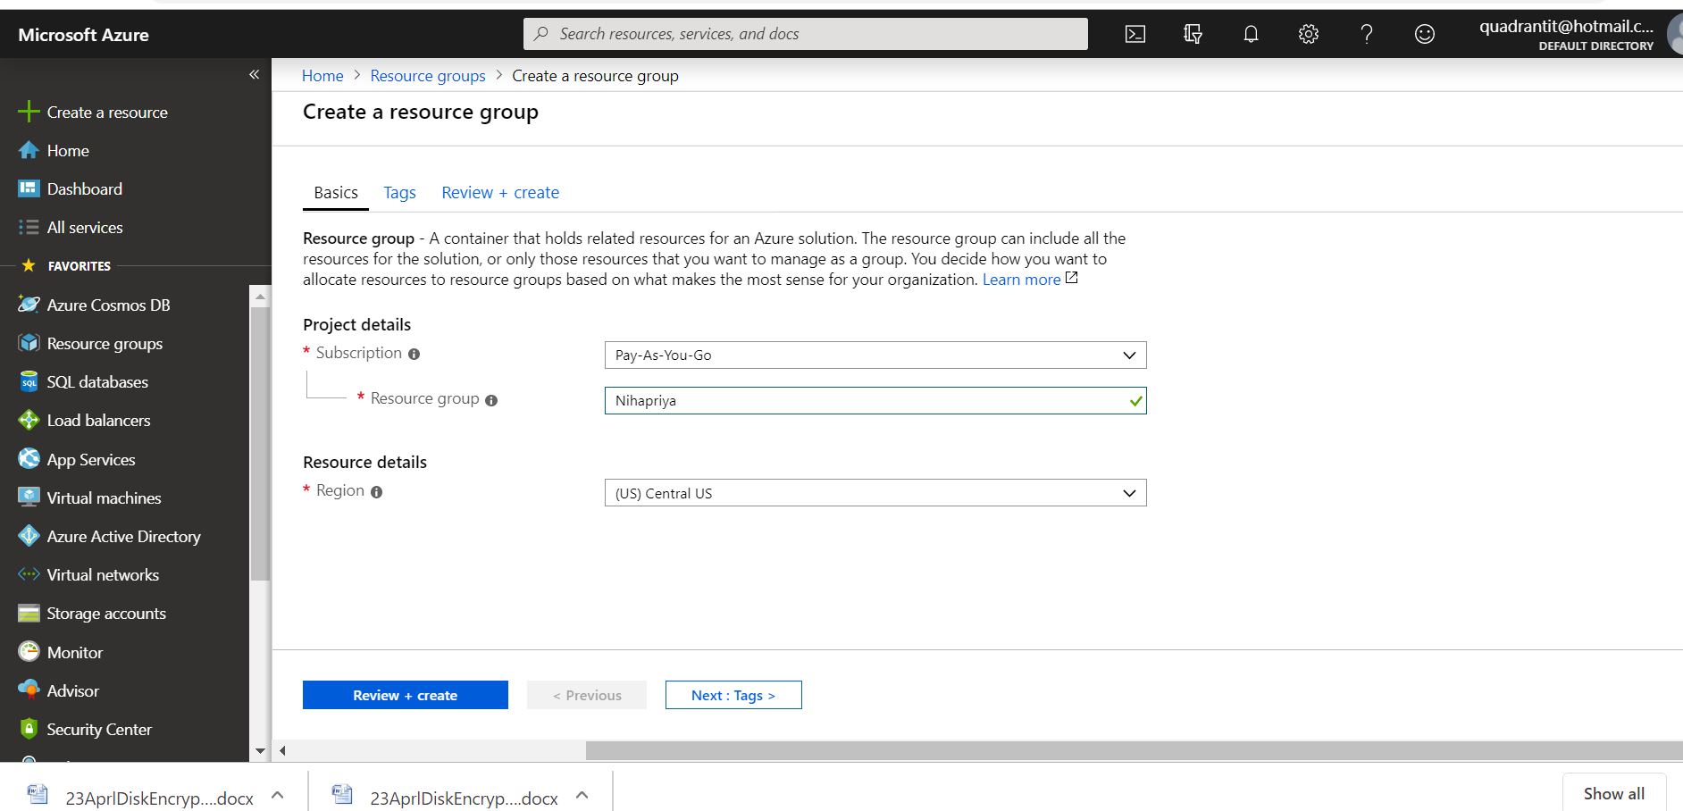

1. **Create A Virtual machine**

**I created NihapriyaVM**

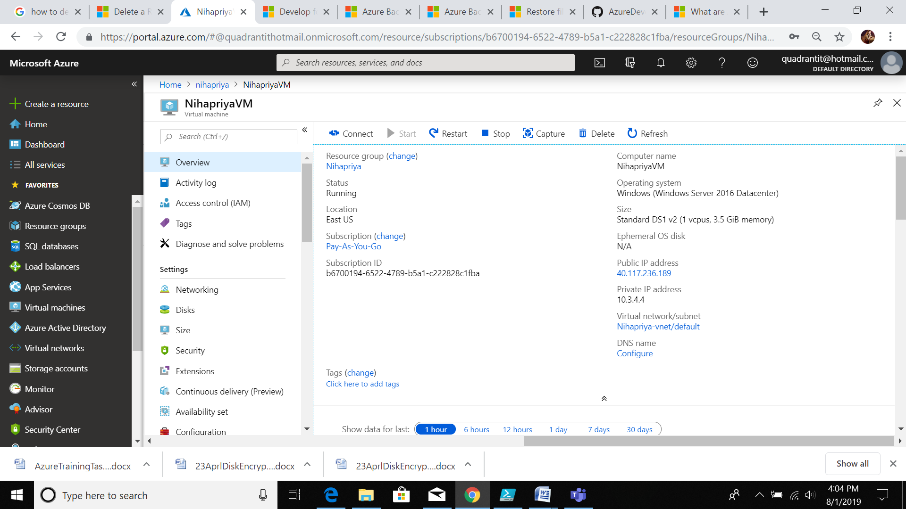

**3.Create App Registtration**

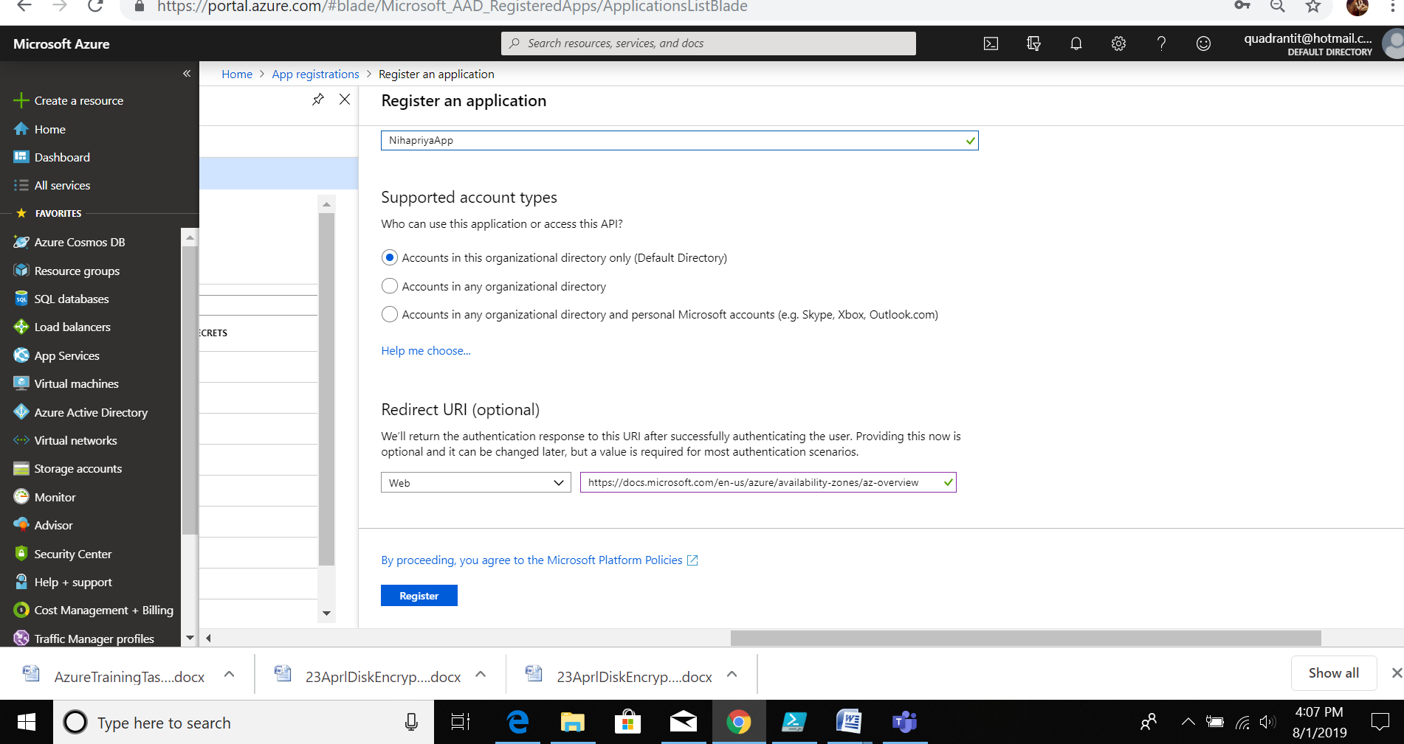

**After creating copy the client app id**

**4.after Registration of app**

**App reg -> Nihapriyaapp-> certificates and secrets -> add client secret**

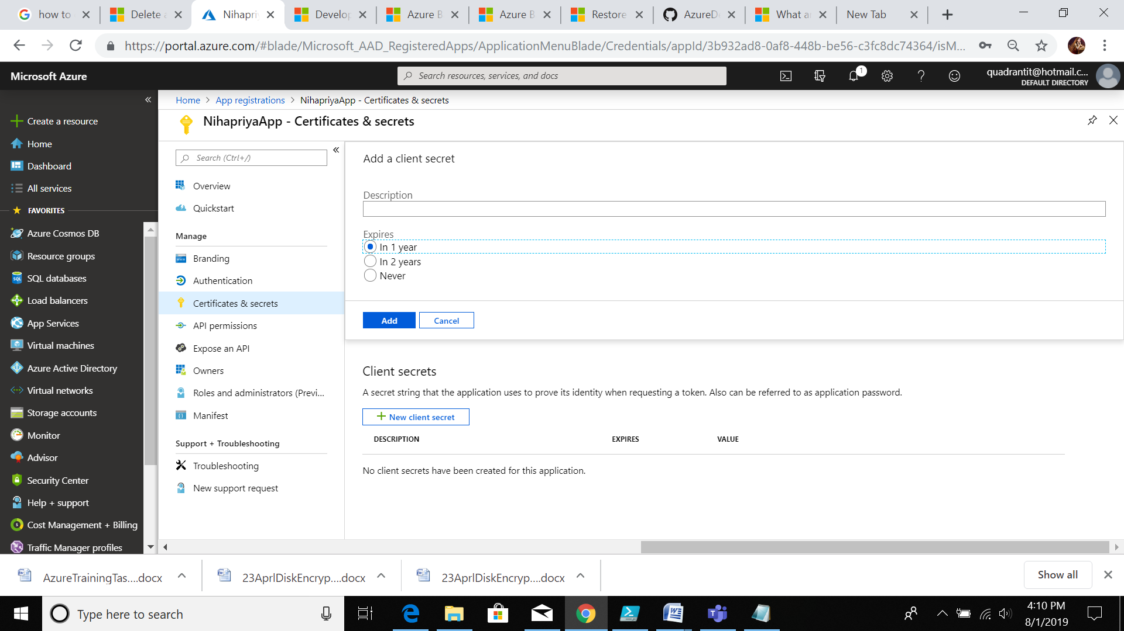

**Copy the secret id**

**5. create key vault**

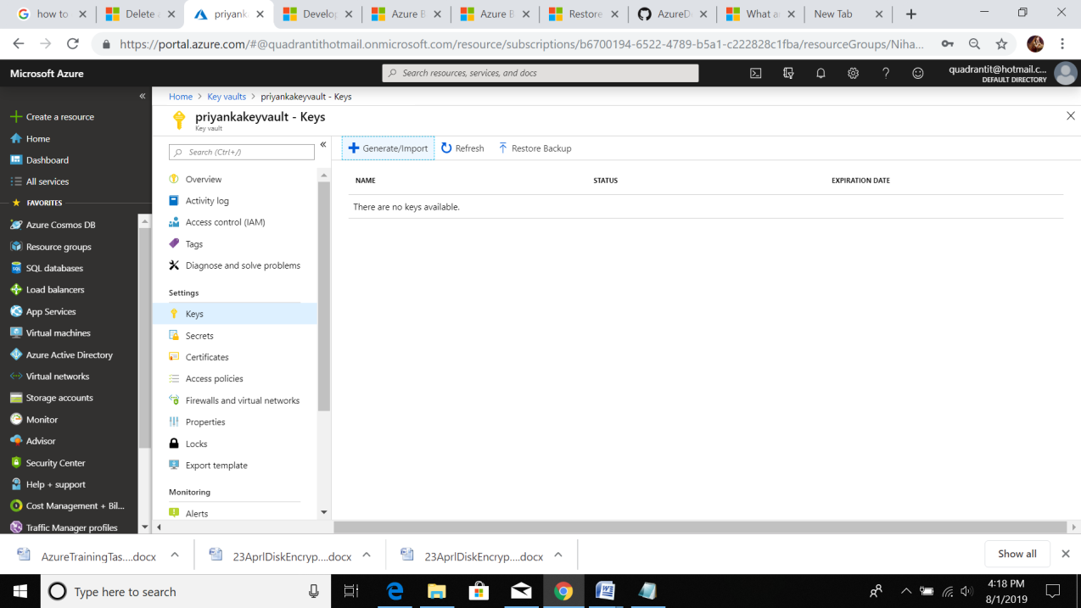

**After that Key vault -> priyankakeyvault -> keys -> generate/importkey**

**After genaration of key copy the key value**

**6.add access policies**

**Priyankakeyvault->accesspolicies -> add accesspolices ->principle ->app registeration name(nihapriyaapp)**

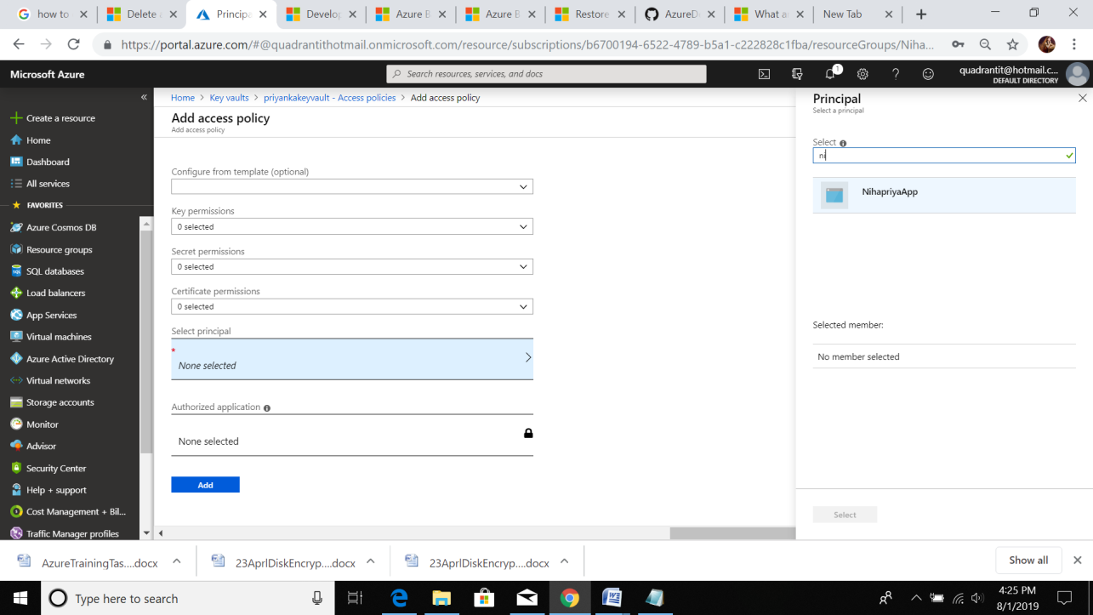

**7.** 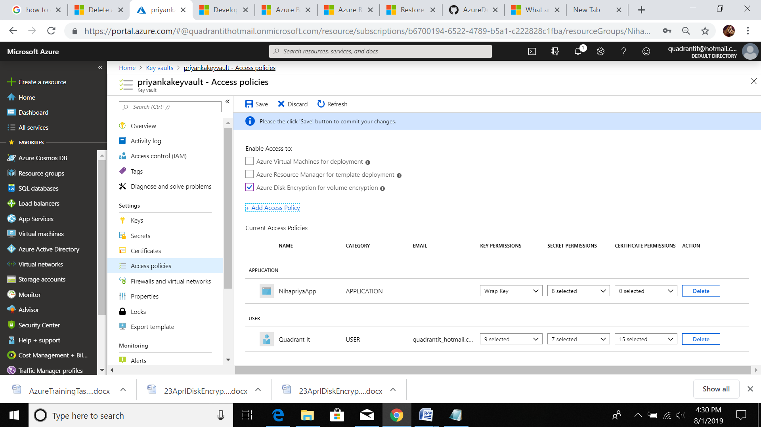

**8. 201-encrypt-running-windows-vm**

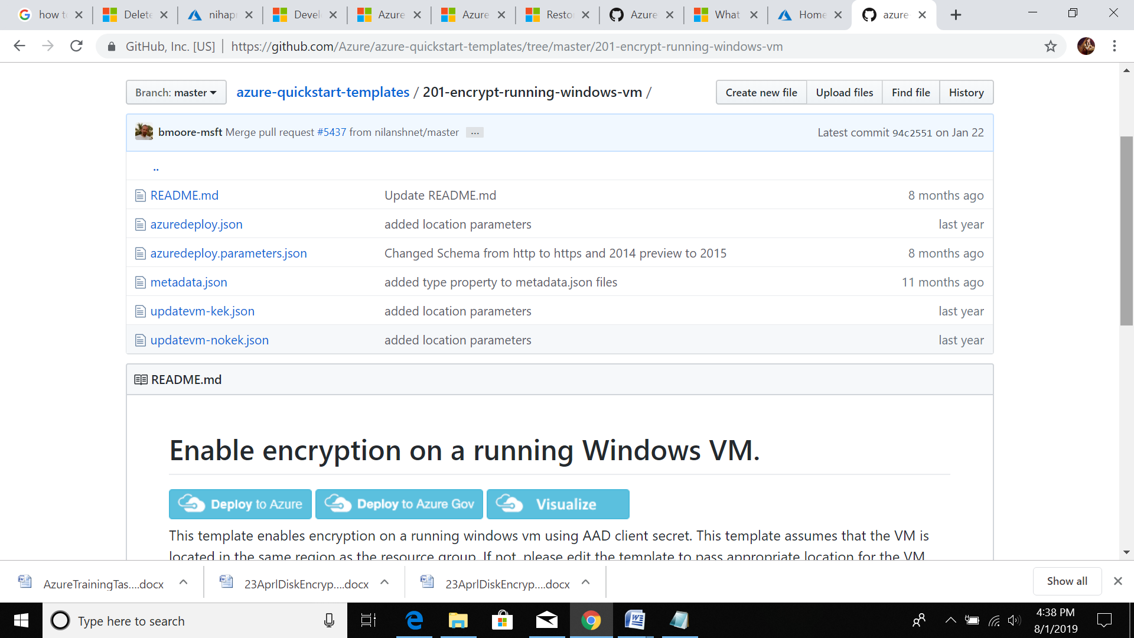

**9.deploye to azure**

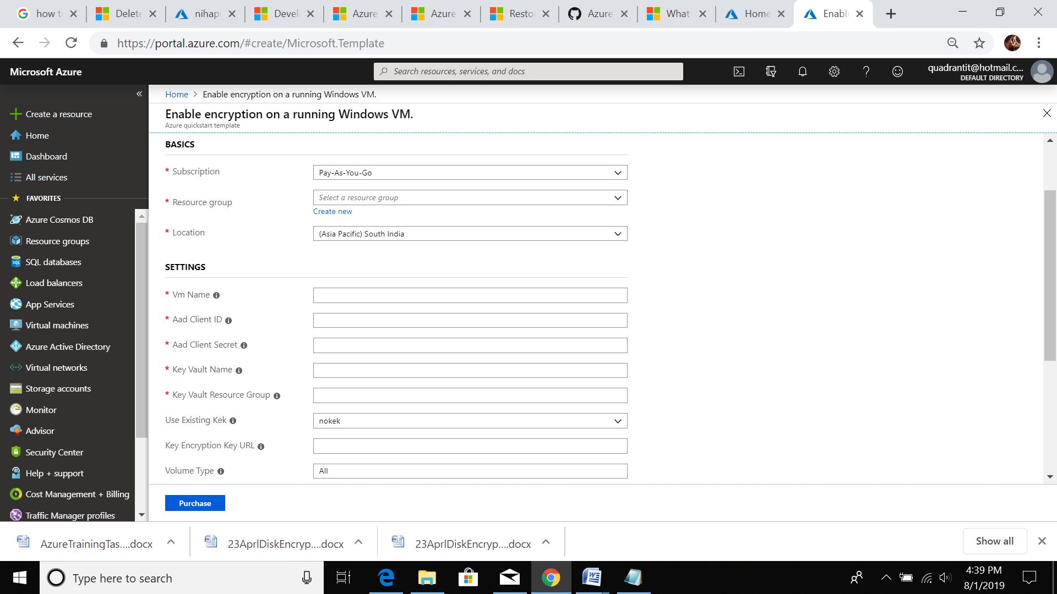

**Here we give app id ,secret id, app register and rg name than click purches**

**10.**

**Go to VM-> Disk->**

